- Short vowels - Fa'tha | Part 1
- Short vowels - Fa'tha | Part 2
- Short vowels - Dhammah | Part 1
- Short vowels - Dhammah | Part 2
- Short vowels - Kasrah | Part 1
- Short vowels - Kasrah | Part 2
- Long vowels - Alif | Part 1
- 3 short vowels in 1 word
- Double fat'ha
- Double dhammah
- Double kasrah
Figure 1 Short vowels - Fa'tha | Part 1
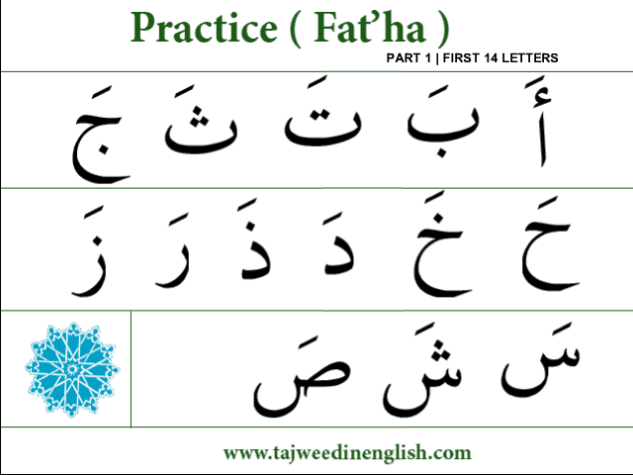

Figure 2 Short vowels - Fa'tha | Part 2
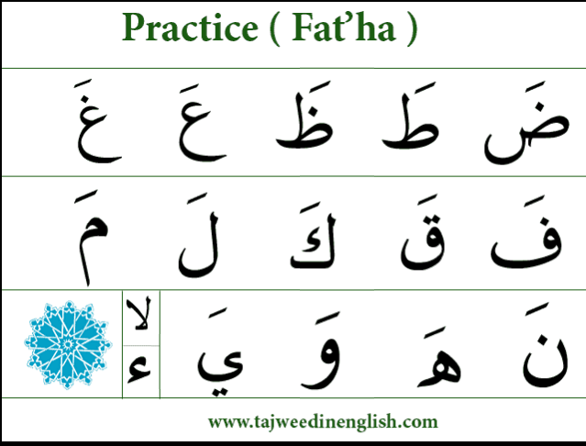

Figure 3 Short vowels - Dhammah | Part 1
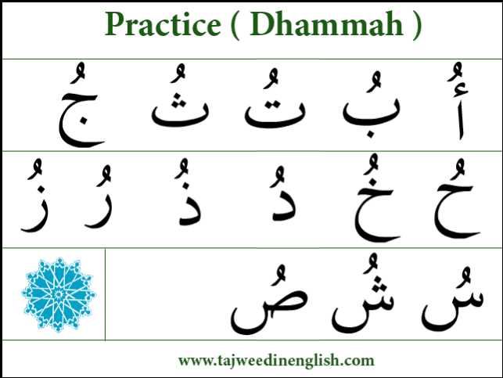

Figure 4 Short vowels - Dhammah | Part 2
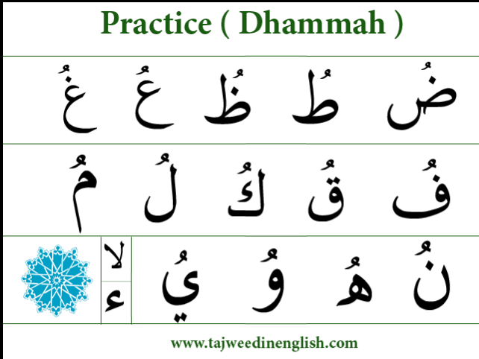

Figure 5 Short vowels - Kasrah | Part 1
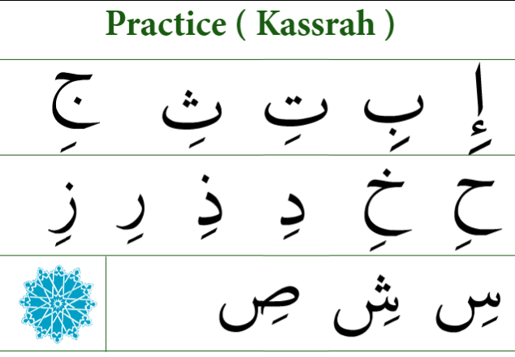

Figure 6 Short vowels - Kasrah | Part 2
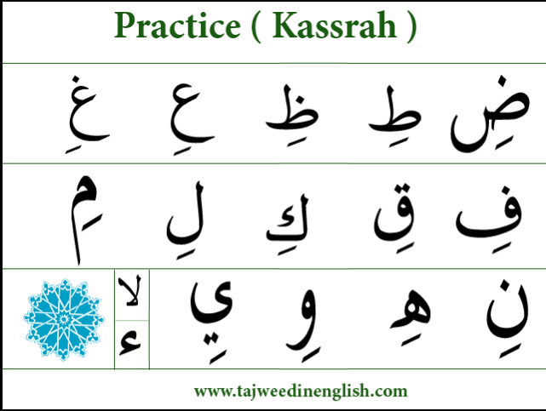

Figure 7 Long vowels - Alif | Part 1
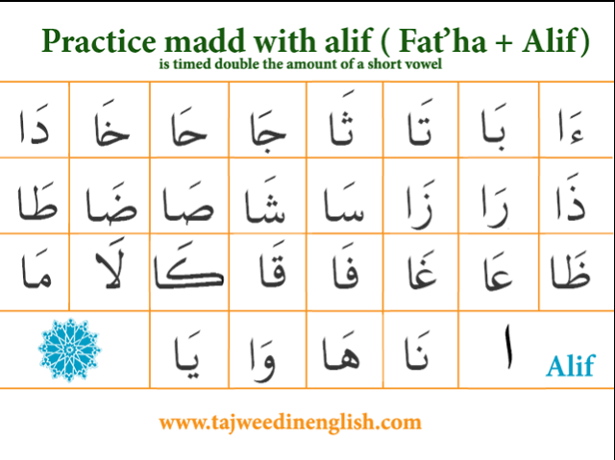

Figure 8 short vowels in 1 word
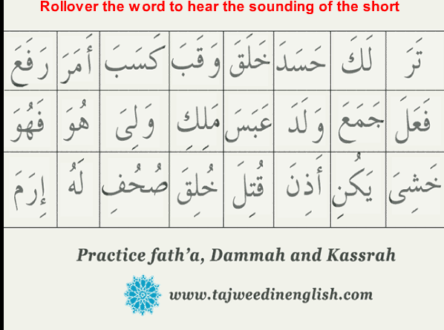

Figure 9 Double fat'ha
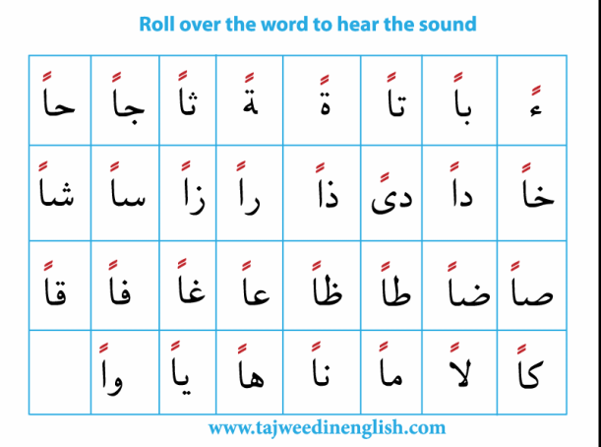
Figure 10 Double dhammah
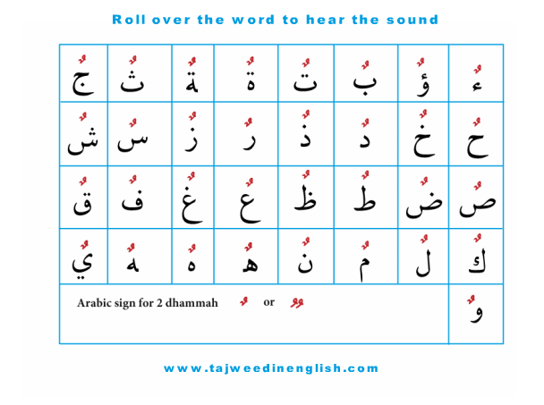
Figure 11 Double kasrah
